Contents

1. Bootstrapping Hibernate – Command-Line 2

1.1 Add the Jar Files 2

1.2 Configuration of Hibernate 3

1.3 Command-Line-Main Class (Customized Class ) 4

1.4 Create SessionFactory 8

1.5 Update Class 9

2. Hibernate Architecture 16

2.1 Lightweight ORM 16

2.2 JPA vs Hibernate 16

2.3 High Level Architecture 17

2.4 Detailed Architecture 17

2.5 Building with Hibernate 18

2.6 Mapping Options 18

2.7 Querying Options 19

3. Transaction Batching and Logging 19

3.1 Running Hibernate under JPA 19

3.1.1 Add the Jars 19

3.1.2 Persistence configuration file 20

3.1.3 Create Entity Manager Class 21

3.2 Catching Data 21

3.2.1 Add the Jars 21

3.2.2 Enable Second Level Catche Configuration 22

3.2.3 EHCache configuration 22

3.2.4 Main Class 23

3.2.5 Enable @Cachable Annotation 24

3.2.6 Run the Application 24

4. Query 25

4.1 Unique Item Query 25

4.1.1 Run the Application 25

4.2 Filtering Data Result 27

4.2.1 Enable Filter Annotation 27

4.2.2 Main Class 27

4.2.3 Run the Application 27

# 1. Bootstrapping Hibernate – Command-Line

## 1.1 Add the Jar Files

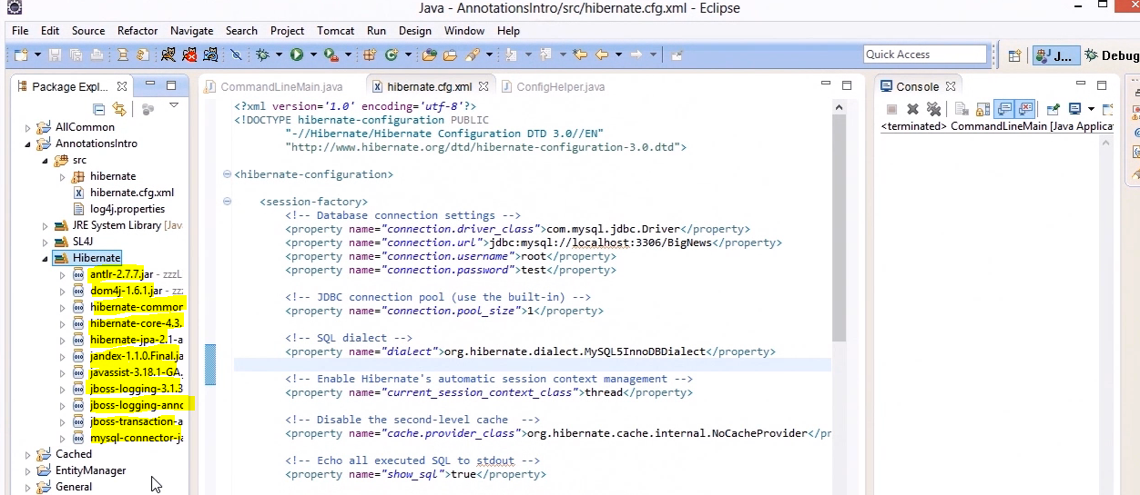

## 1.2 Configuration of Hibernate

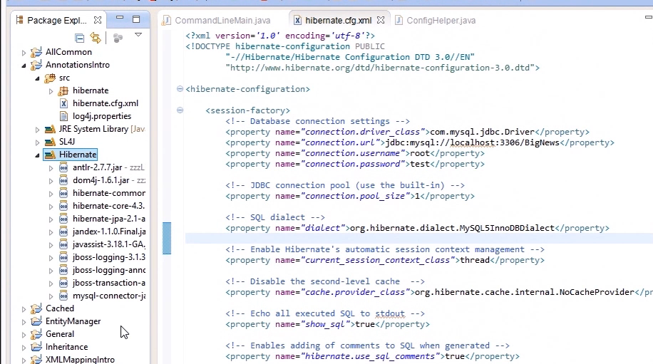

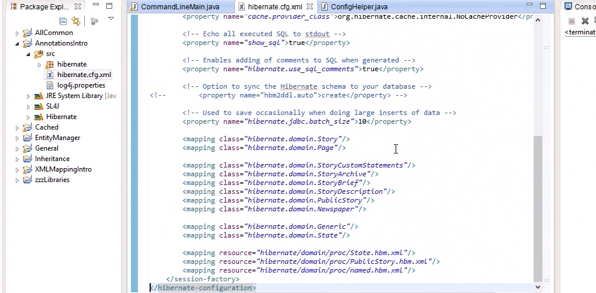

## 1.3 Command-Line-Main Class (Customized Class )

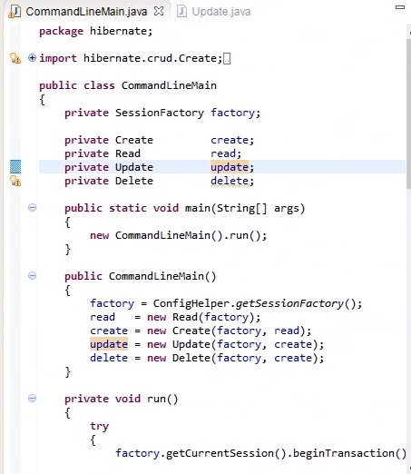

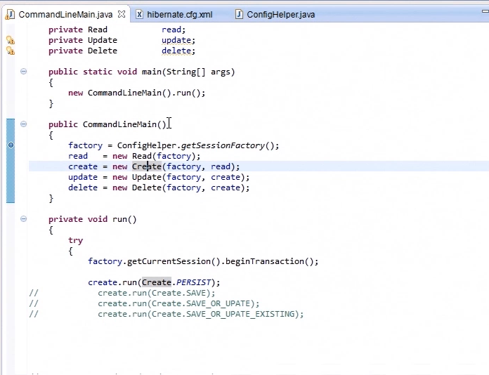

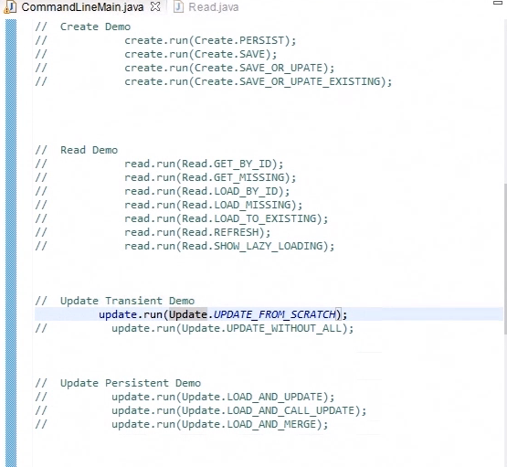

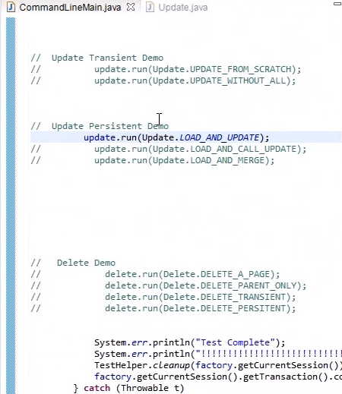

## 1.4 Create SessionFactory

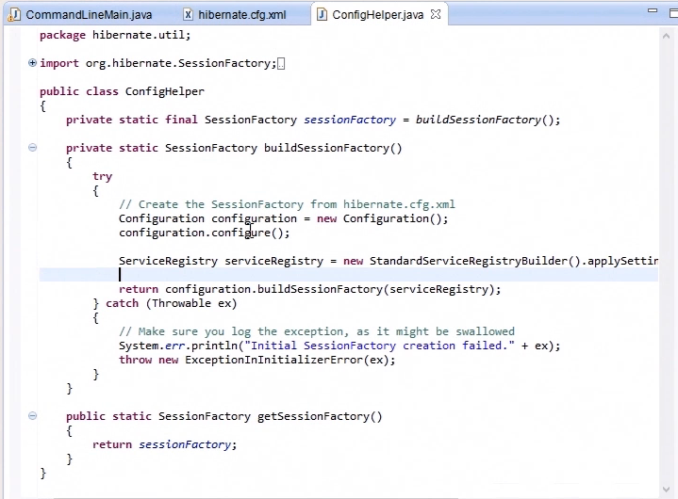

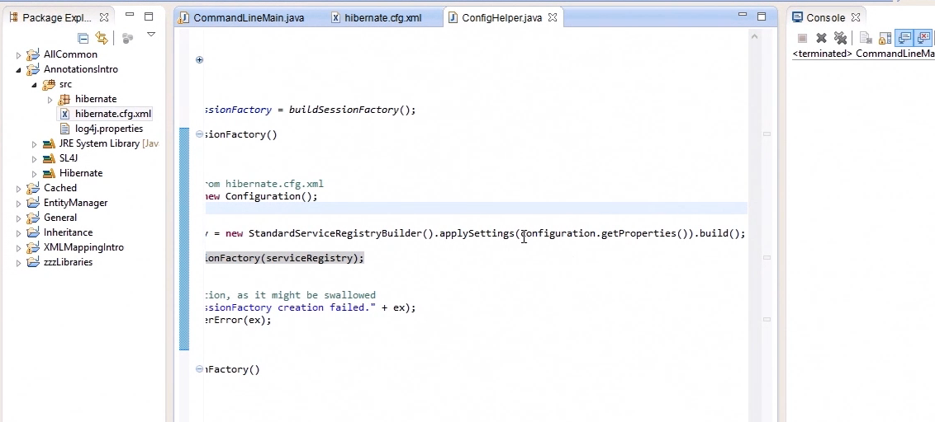

## 1.5 Update Class

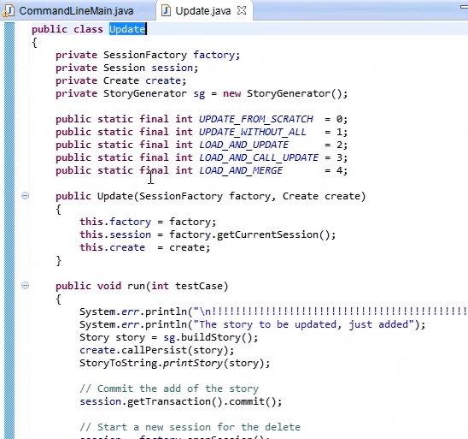

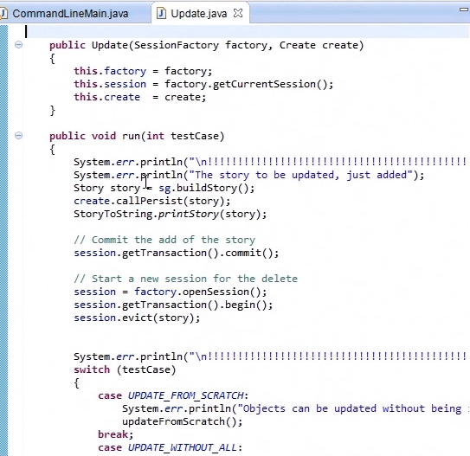

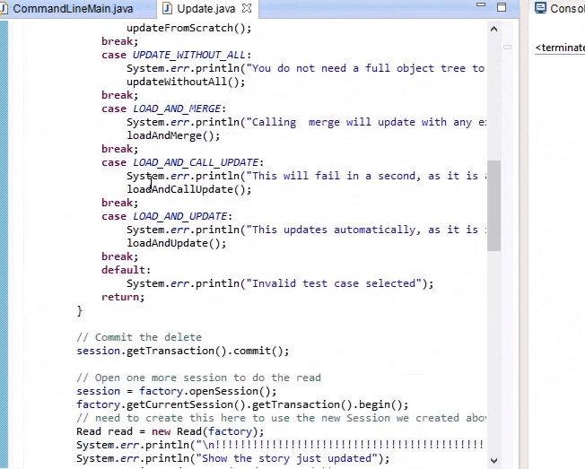

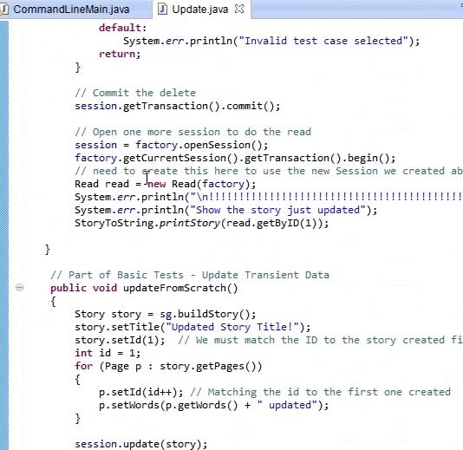

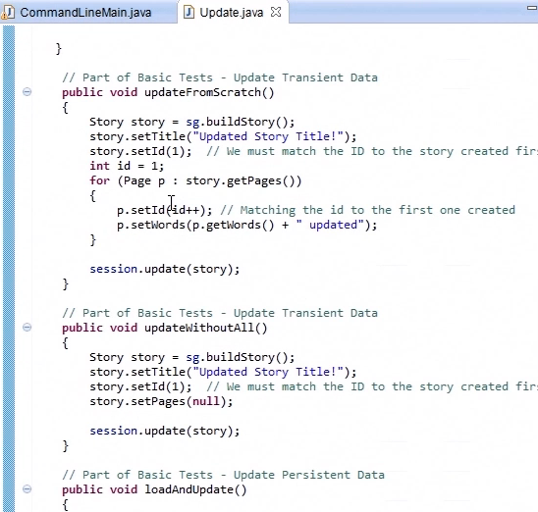

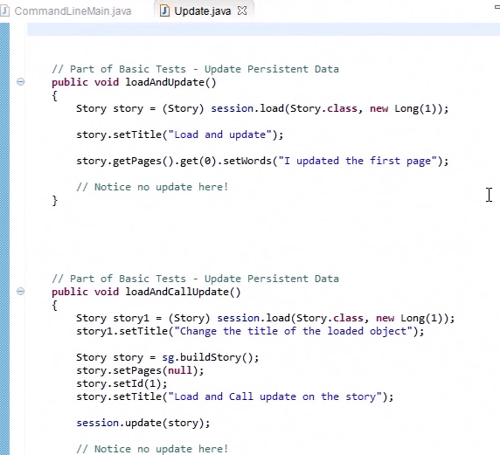

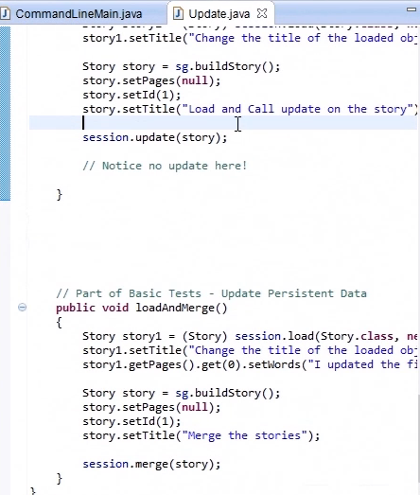

# 2. Hibernate Architecture

## 2.1 Lightweight ORM

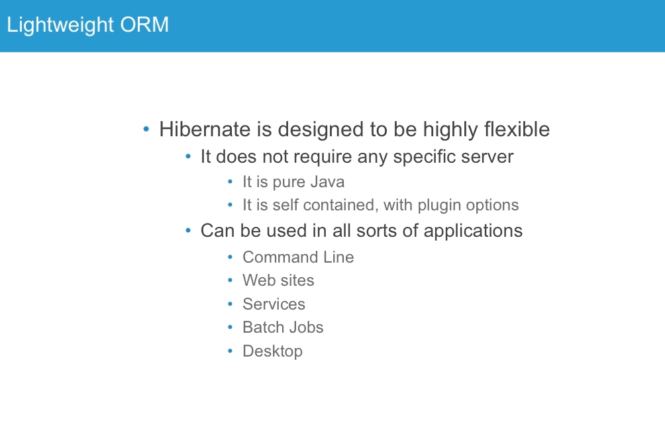

## 2.2 JPA vs Hibernate

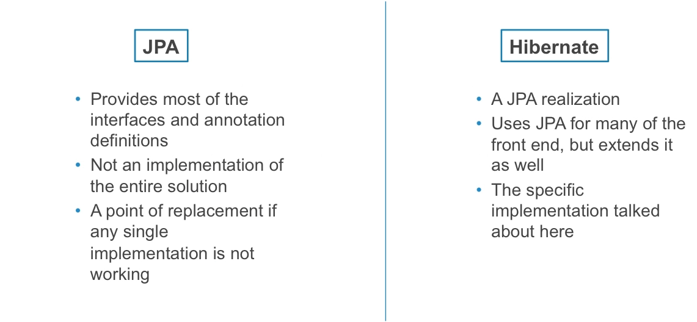

## 2.3 High Level Architecture

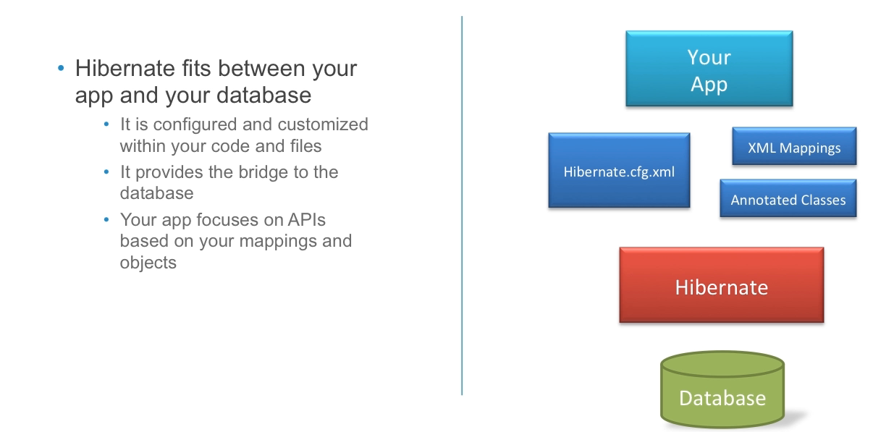

## 2.4 Detailed Architecture

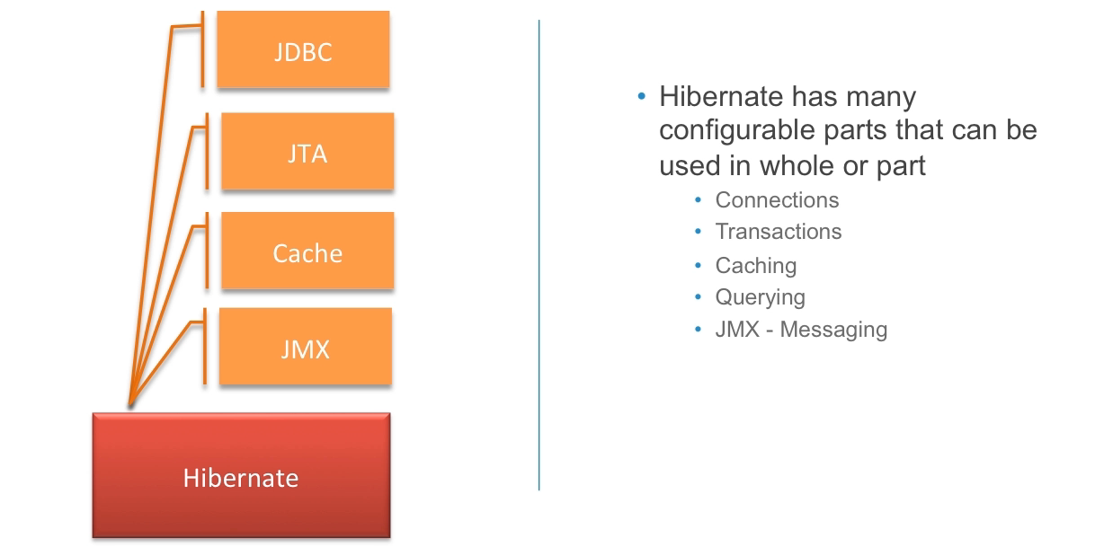

## 2.5 Building with Hibernate

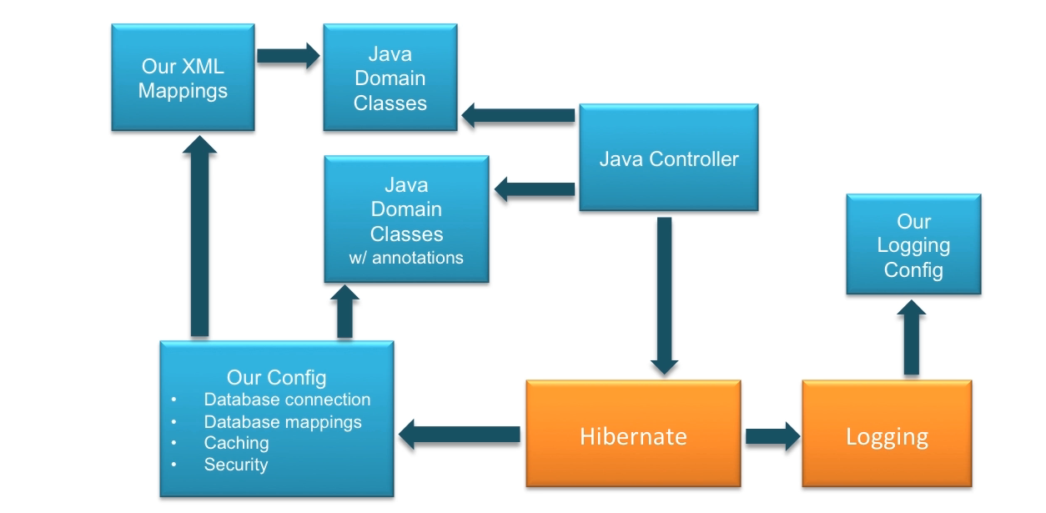

## 2.6 Mapping Options

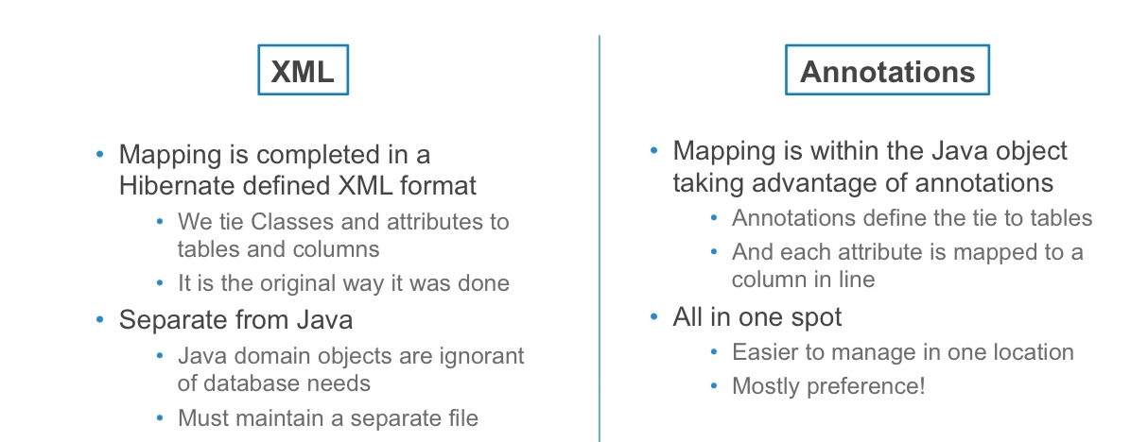

## 2.7 Querying Options

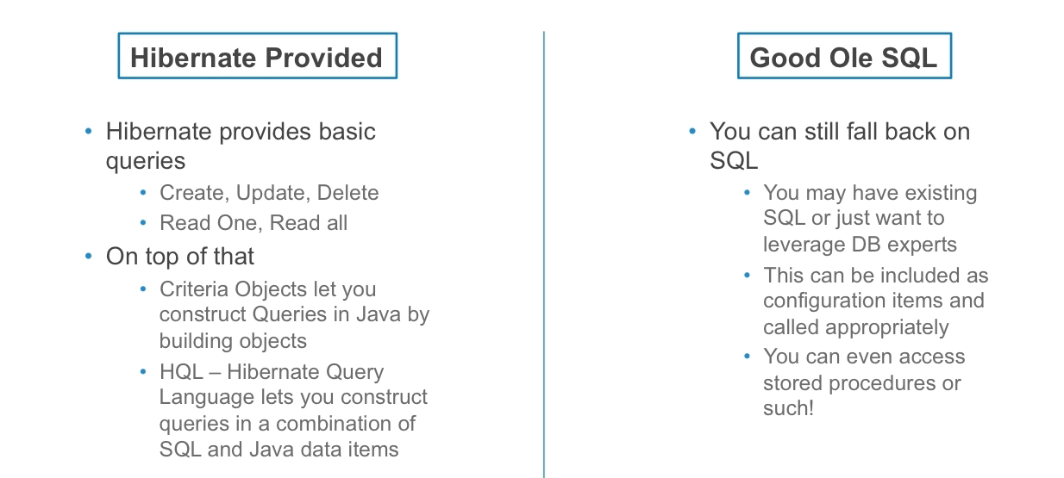

# 3. Transaction Batching and Logging

## 3.1 Running Hibernate under JPA

### 3.1.1 Add the Jars

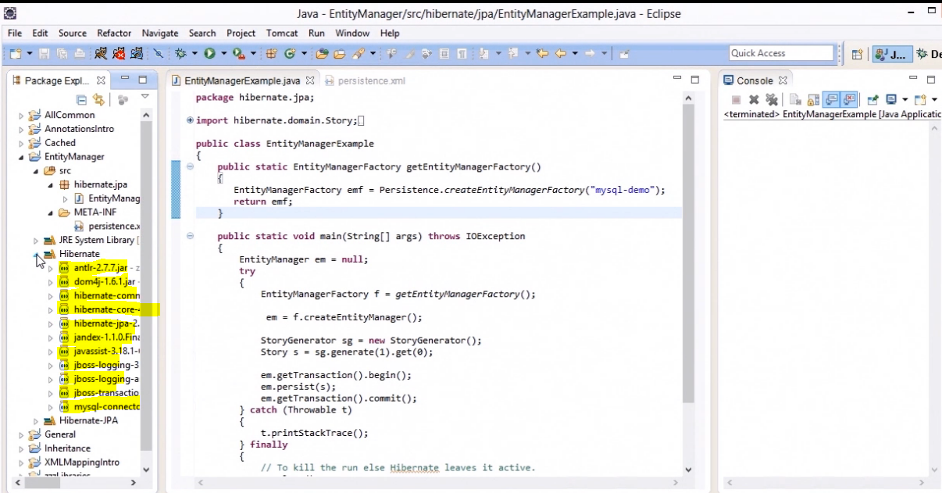

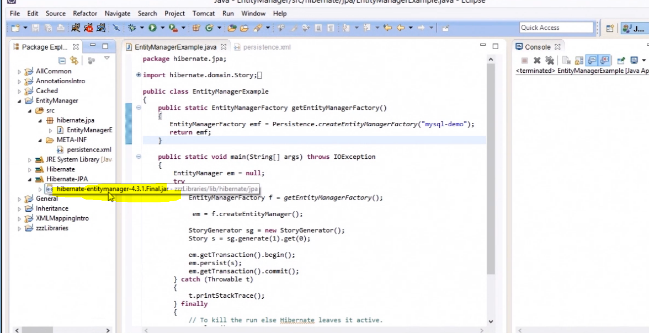

### 3.1.2 Persistence configuration file

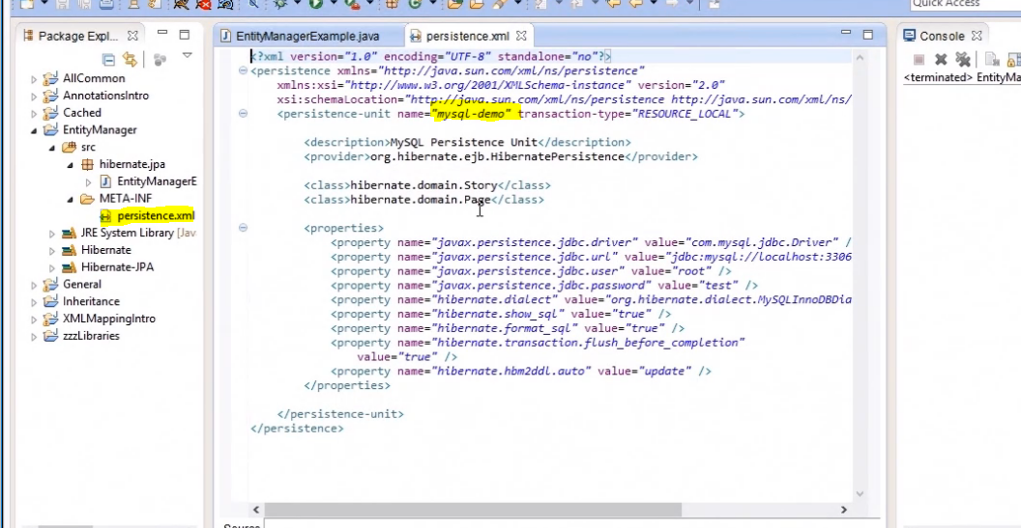

### 3.1.3 Create Entity Manager Class

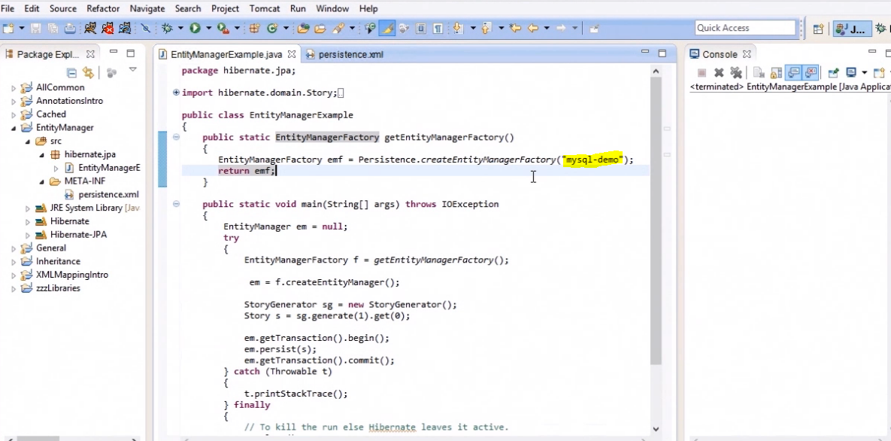

## 3.2 Catching Data

### 3.2.1 Add the Jars

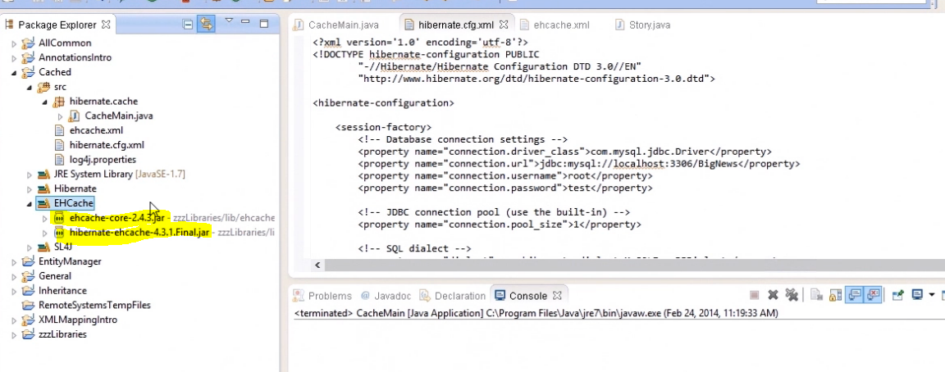

### 3.2.2 Enable Second Level Catche Configuration

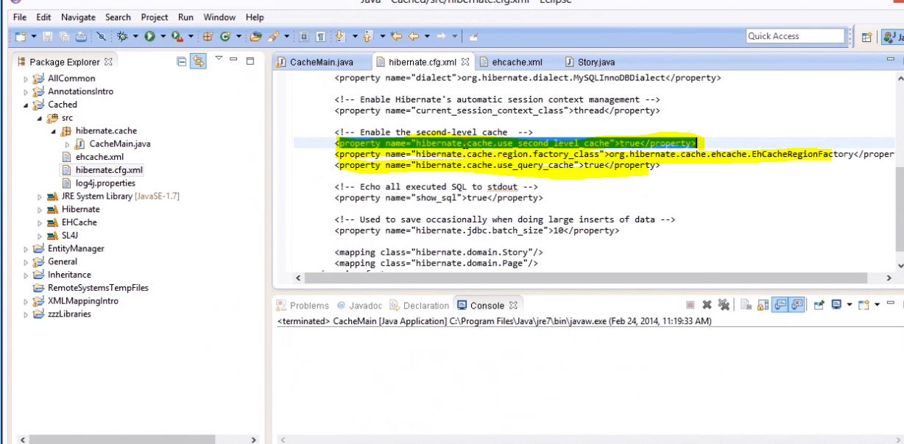

### 3.2.3 EHCache configuration

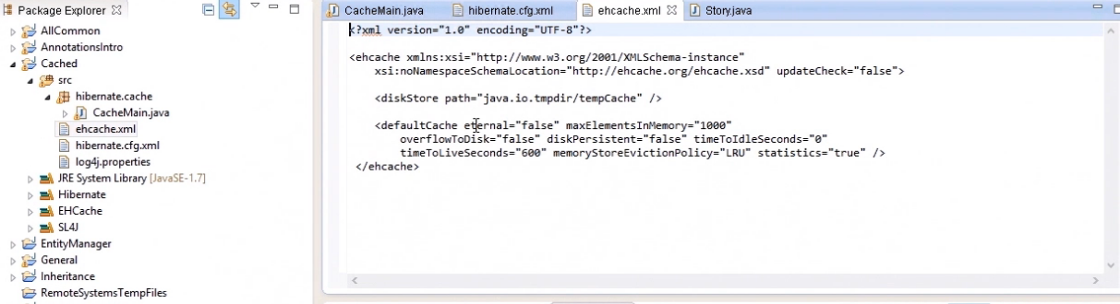

### 3.2.4 Main Class

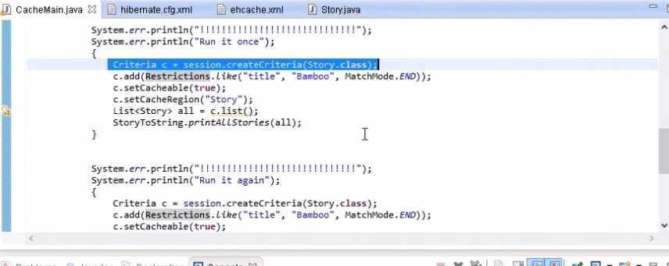

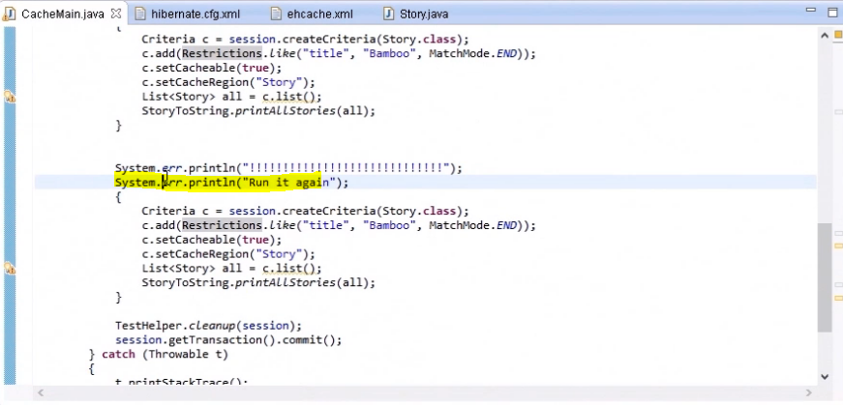

### 3.2.5 Enable @Cachable Annotation

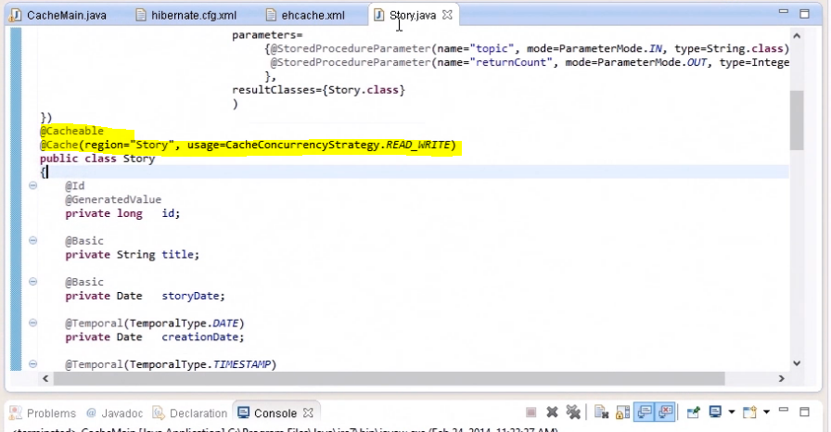

### 3.2.6 Run the Application

First time Running

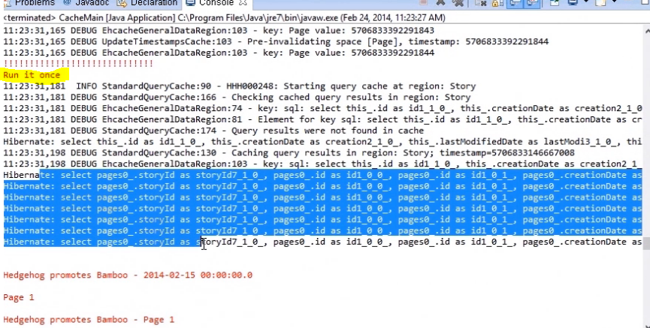

Second time running. It’s not calling querys

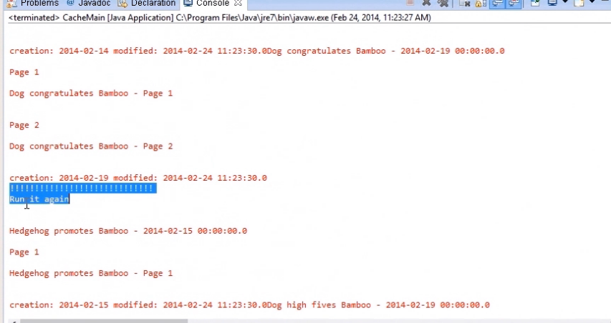

## 4. Query

## 4.1 Unique Item Query

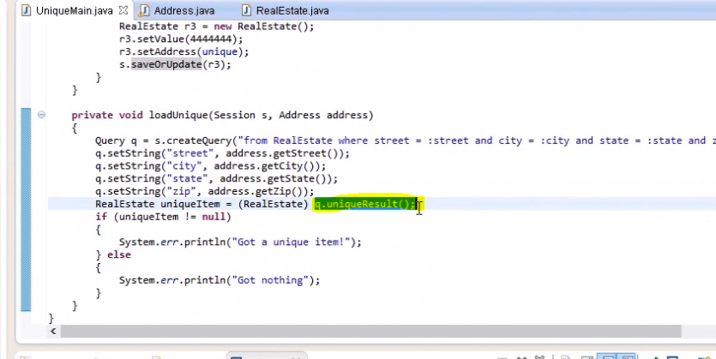

### 4.1.1 Run the Application

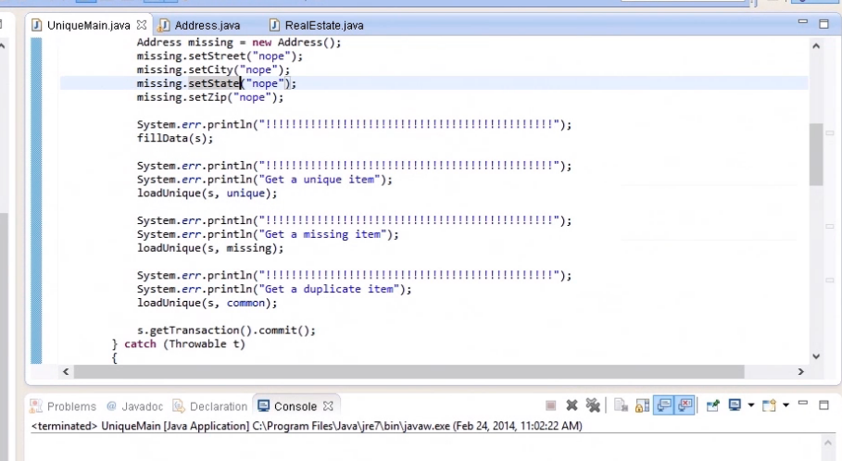

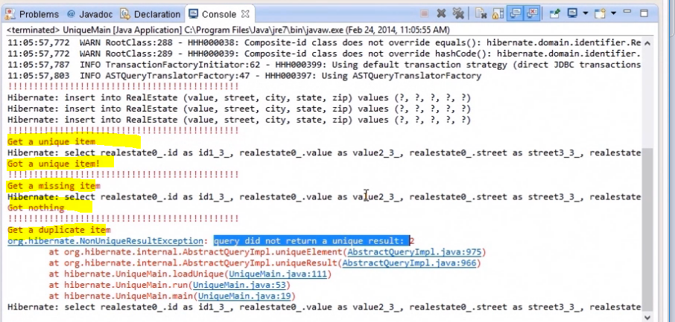

## 4.2 Filtering Data Result

### 4.2.1 Enable Filter Annotation

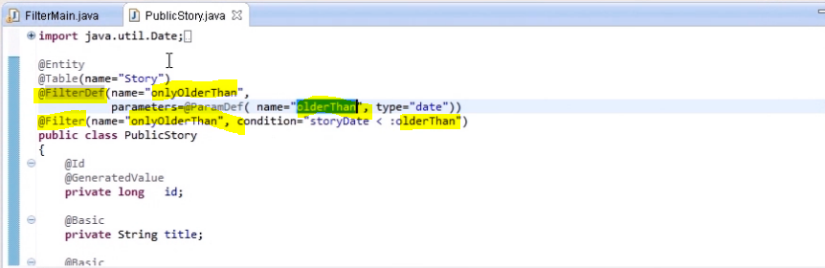

### 4.2.2 Main Class

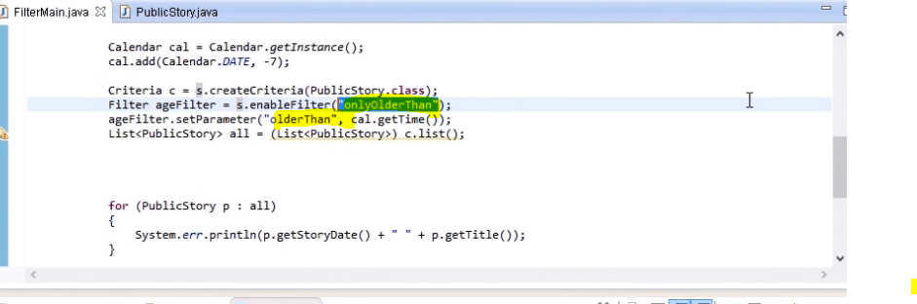

### 4.2.3 Run the Application

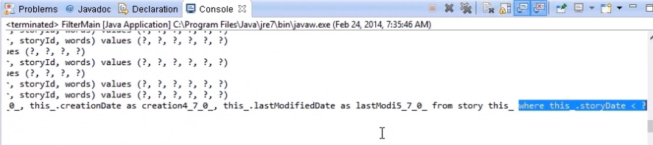

Where condition automatically add in hiberanate query based and Filter parameter in Main class we are set. If we are not set filter parameter in main class then it will return all values (won’t add where condition)

